1. 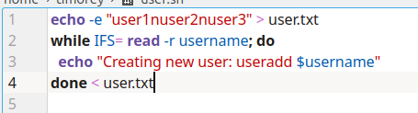
2. 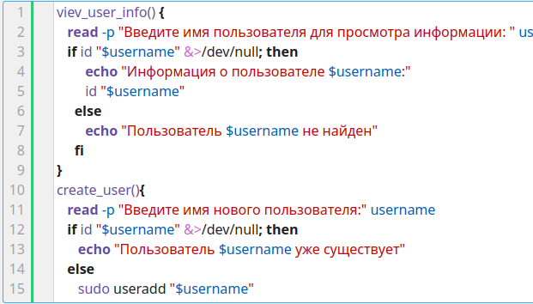

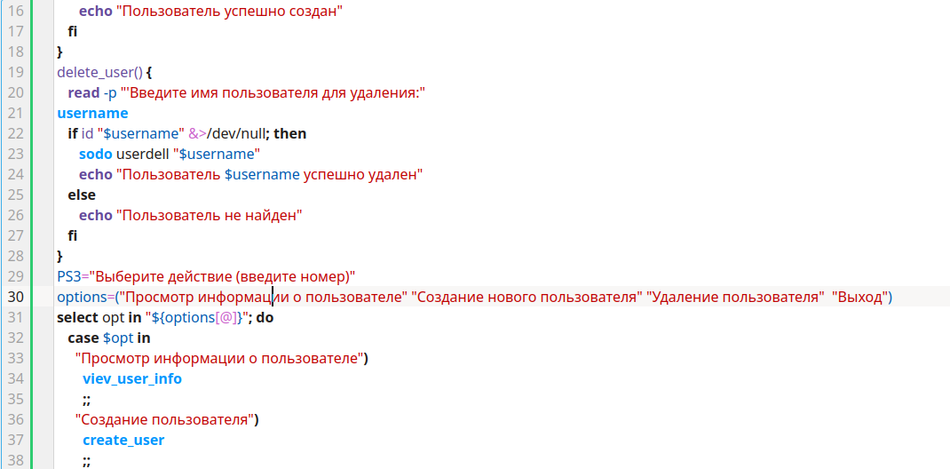

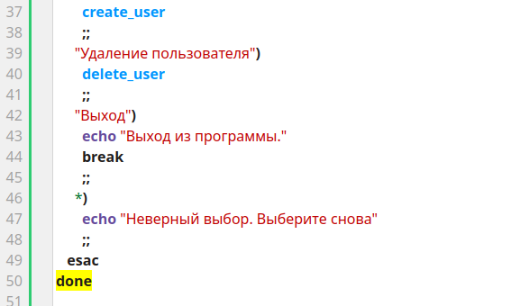

| #3 |  |
| --- | --- |
|  | echo " |
|  | Введите ваше имя |
|  | " |
|  | read username |
|  | grep -m 1 "$username" /etc/passwd |
|  |  |
|  | 4) |
|  | date=$(date +%d_%m_%Y) |
|  | tar acf "/home/backup/backup_$name_$date.tar.gz" /data/* |
|  |  |
|  | 5) |
|  | echo " |
|  | Введите имя файла |
|  | " |
|  | read file_name |
|  | touch "$file_name" |
|  |  |
|  | echo " |
|  | Введите права файла в числовом формате |
|  | " |
|  | read rights |
|  | chmod "$rights" "$file_name" |
|  |  |
|  | 6) |
|  | echo " |
|  | Введите ваше имя |
|  | " |
|  | read username |
|  | grep -m 1 "$username" /etc/passwd | cut -d':' -f7 |